Course Info: When & where will we learn? How can you contact me?
Time & Location: Mondays 5:00-7:40 pm | Zoom meetings in odd-numbered weeks
Instructor: Dr. Dan Reynolds| Admin 308 | Cell: (512) 774-9394 | Email: dreynolds@jcu.edu
Office Hours: Th 4-5pm and 7:40-8:40pm, Mon 4-5pm and 7:40-8:40pm.
**I am available many other times by appointment– click this link to schedule a time to meet.

Course Rationale: Why should I learn this?
Designing a high-quality curriculum is a critical task for ELA teachers. According to the Ohio Reading and Literacy Endorsement Standards (2018, see p. 8 of this document), endorsement candidates must learn to design responsive literate environments for curriculum instruction (Std. 3), demonstrate cultural competence in pedagogical design (Std. 2), integrate comprehension across genres and contents (Std. 5), and demonstrate capacity in professional literacy leadership, collaboration, and communication (Std. 8). As such, this course prepares candidates for literacy leadership.

Course Objectives: What will I be able to do after this course?
- Analyze student characteristics relevant to literacy instruction, and, in turn, analyze equity and cultural responsiveness of ELA curriculum.
- Design historically responsive literacy curriculum that advocates for equity in literacy instruction and school policy.
- Develop backward-design curriculum that applies UbD principles for ELA instruction.
- Demonstrate literacy leadership skills by locating, sharing, and discussing high-quality resources in literacy with a professional community.
- Integrate knowledge of curriculum design, student characteristics, historically just literacy pedagogy, and professional learning concepts into curriculum artifacts.

Curriculum Matrix: How will we meet these course objectives?

Objective Number | Objective & Skills | Readings/Learning Activities | Assignments
1 | Analyze students and curriculum | Weeks 1-3 readings and in-class activities | School/class profile and curriculum audit
2 | Historically responsive literacy curriculum | Cultivating Genius text/discussions and activities | Online discussions  Three-stage unit plan  Two-stage curriculum guide
3 | Backward design for curriculum | Understanding by Design text/discussions  And activities | Online discussions  Unit Design  Curriculum guide
4 | Literacy leadership | Research discussions | Research discussions
5 | Integrative knowledge for instruction | All | Curriculum guide

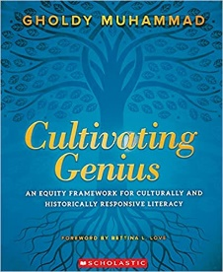
Course Texts: Whose ideas will inform our learning?
Required texts for whole-class discussion: One Paper text, one Perusall text
- Buy on Paper: Muhammad, G. (2020) Cultivating Genius: An Equity Framework for Culturally and Historically Responsive Literacy.
- Buy on Perusall: Wiggins, G & McTighe, J. (2011). The Understanding By Design Guide to Creating High Quality Units. 1st ed.
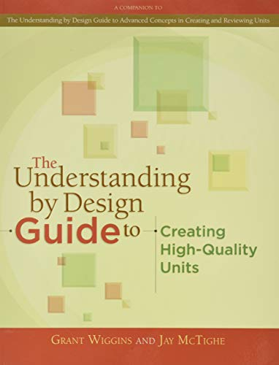
Required journals for research discussions (free access via JCU Library)
- The Reading Teacher (ILA for elementary)
- Language Arts (NCTE for elementary)
- Voices from the Middle (NCTE for middle level)
- Journal of Adolescent & Adult Literacy (ILA for middle/AYA)
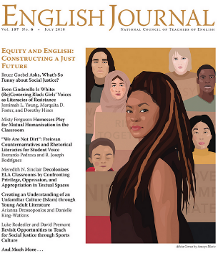
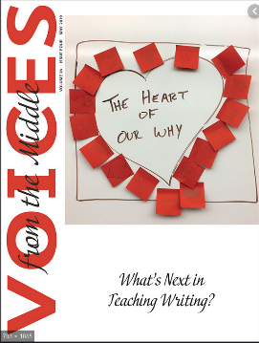
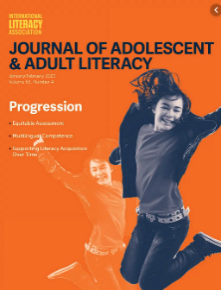
- English Journal (NCTE for high school)

Assignments: How will understanding be demonstrated?
Discussions of CG and UbD text (10%). During our asynchronous weeks, we will have discussions on Canvas (Cultivating Genius text) and Perusall (Understanding By Design text), as well as occasional posts on Canvas about course projects and topics. These discussions will happen on Zoom during synchronous weeks.
Research Discussions (20%). Each week, after you read the assigned reading from CG and UbD, and reflecting on their application to your school context, you’ll search for high-quality research on ELA instruction that extends your learning. You’ll share the article to Canvas and discuss with classmates. These sources will, in turn, be used to inform the three major assignments below.
School/Class Profile and Curriculum Audit (20%). Before beginning your literacy design work, it’s imperative to deeply investigate who your students are and what your existing curriculum is. This is a 3-4 page paper (with accompanying data tables) in which you analyze the demographic and personal characteristics of your students and list your existing ELA curriculum units, texts, and standards.
Three-Stage UbD/HRL Unit Plan (20%). Combining the UbD guidelines and the HRL framework, you will design a unit plan aligned with Ohio standards and for the students in your school/class profile and integrated with your curriculum audit. You’ll do this in three stages over three weeks. A template will be provided for you to add on to each week.
Two-Stage Curriculum Guide (30%). Extending the learning you do in your three-stage unit plan, you will build a 4-unit curriculum for an ELA course in your school and grade. Using the UbD and HRL frameworks, you’ll select unit topics, align to Ohio standards, select texts, and design learning plans. You’ll leave the course with a fully designed ELA course to bring to your work. You are encouraged to build on, adapt, and integrate existing resources.

Course Schedule: What’s the plan for accomplishing the objectives?

 | Date | Topic | Read and Discuss | Major Assignments due this week
1 | 1/24* | Course intros, overview, HRL and UbD frameworks | In class: NCTE resolution | Start research discussions in class  Begin school/class profile.
2 | 1/31 | HRL Framework: History | CG Foreword, Introduction, and Part I | Decide on grade and course for unit plan and curriculum guide. Begin collecting data for school and class profile.
3 | 2/7* | HRL Framework: Identity | CG Ch 3 | Draft of school & class profile
4 | 2/14 | HRL Framework: Skills | CG Ch 4 | Draft of curriculum audit
5 | 2/21* | HRL Framework: Intellect | CG Ch 5 | Final copy of school/class profile & curriculum audit
6 | 2/28 | HRL Framework: Criticality | CG Ch 6 | Analyze sample unit plans and post comments.
7 | 3/14* | HRL Framework: Texts & Lessons | CG Ch 7-8 | HRL Unit Overview Draft
8 | 3/21 | UbD Framework: Concepts | UbD Module A+B+C | None
9 | 3/28* | UbD Framework: Goals | UbD Module E+F | Stage 1 UbD/HRL unit plan due: Desired Results
10 | 4/4 | UbD Framework: Evidence | WM Module G | Stage 2 of UbD/HRL unit plan due: Evidence
11 | 4/11* | UbD Framework: Learning Plans | WM Module H | Stage 3 of UbD/HRL unit plan due
12 | 4/19 | Text Selection Frameworks | TBD by students: texts | Stage 3 of UbD Plan Due: Learning Plan
13 | 4/25* | TBD by instructor | TBD by instructor | None
14 | 5/2 | TBD by students’ research discussions | TBD by students | Curriculum Guide Stage 1 Due: Goals and Tasks
15 | 5/9 | No new topic- work on final! | None | Curriculum Guide Stage 2 Due: Goals, Tasks, Evidence, and Texts
* Weeks marked with asterisk indicate synchronous meeting on Zoom. All other weeks asynchronous.

Course Policies
Zoom Attendance: Regular attendance and active participation are expected. With advance permission of the instructor, absences from Zoom sessions may be excused. It is also crucial that you discuss absences with me so that I can plan course activities accordingly. For that reason, attendance penalties are specified in the table below
If the absence was…. | Excusable | Unexcusable
Discussed with Dan before class | 0 | 0.5
Not discussed with Dan before class | 1 (except emergencies) | 2
**I reserve the right to ask for documentation about excusable absences. Absences not discussed will be assumed unexcusable. Please talk to me—I am very understanding when it comes to individual needs and situations (I’ve been there and I have needed to ask for excusability before), but not showing up and not communicating is not an option for a teacher! Deductions come out of the online discussion grade.
Late Work: Timely work is critical for me to give you meaningful feedback. Unless special circumstances have been, late assignments will receive a 10% penalty. You are encouraged to contact me before the assignment is due to discuss challenges in submitting on time, and deadlines can certainly be extended.
Submitting Assignments All assignments are to be typed, using APA style (6th ed.) Unless otherwise directed, all assignments must be submitted electronically at the time specified on Canvas.
Assignment Rewrites: To focus on mastery of the course content, all assignments can be rewritten and resubmitted at any point in the semester. Revisions must include highlighting to show what was changed. All revisions should be resubmitted to the original Canvas assignment.
APA Style. My insistence on APA style is not intended to frustrate you on the minutiae of formatting (though I know it is a frustrating process to learn). It is intended to support you in writing and reading in the language of our profession. Nearly all journal articles, textbooks, and professional writing in education are written in APA style, and the better you master APA, the better you will read and write as a leader in our field.

How Perusall Works & Rubric (source: Perusall.com)
Perusall helps you master readings faster, understand the material better, and get more out of your classes. To achieve this goal, you will be collaboratively annotating the textbook with others in your class. The help you’ll get and provide your classmates (even if you don’t know anyone personally) will get you past confusions quickly and will make the process more fun. While you read, you’ll receive rapid answers to your questions, help others resolve their questions (which also helps you learn), and advise the instructor how to make class time most productive. You can start a new annotation thread in Perusall by highlighting text, asking a question, or posting a comment; you can also add a reply or comment to an existing thread. Each thread is like a chat with one or more members of your class, and it happens in real time. Your goals in annotating each reading assignment are to stimulate discussion by posting good questions or comments and to help others by answering their questions.
Research shows that by annotating thoughtfully, you’ll learn more and get better grades, so here’s what “annotating thoughtfully” means: Effective annotations deeply engage points in the readings, stimulate discussion, offer informative questions or comments, and help others by addressing their questions or confusions. To help you connect with classmates, you can “mention” a classmate in a comment or question to have them notified by email (they’ll also see a notification immediately if online), and you’ll also be notified when your classmates respond to your questions.
For each assignment we will evaluate the annotations you submit on time (see below). Based on the overall body of your annotations, you will receive a score for each assignment as follows
3 = demonstrates exceptionally thoughtful and thorough reading of the entire assignment
2 = demonstrates thoughtful and thorough reading of the entire assignment
1 = demonstrates superficial reading of the entire assignment OR thoughtful reading of only part of the assignment
0 = demonstrates superficial reading of only part of the assignment
Dan’s note: For this course, I will be using threshold scoring. So as long as you hit a “2” on the Perusall scoring rubric, you will get full credit for the assignment.
How many annotations do I need to enter?
When we look at your annotations we want them to reflect the effort you put in your study of the text. It is unlikely that that effort will be reflected by just a few thoughtful annotations per assignment. On the other extreme, 30 per assignment is probably too many, unless a number of them are superficial or short comments or questions (which is fine, because it is OK to engage in chat with your peers). Somewhere in between these two extremes is about right and, thoughtful questions or comments that stimulate discussion or thoughtful and helpful answers to other students’ questions will earn you a higher score for the assignment. Note, also, that to lay the foundation for understanding the in-class activities, you must familiarize yourself with each assignment in its entirety. Failing to annotate the entire assignment will result in a lower score.
Dan’s note: I have set a minimum of 7 comments for each Perusall assignment. You are strongly encouraged to go beyond that, but you cannot receive full credit without at least that many comments.

University Policies
Academic Honesty: Academic Honesty, expected of student, is essential to the process of education and to upholding high ethical standards. Cheating or any other kind of unethical behavior is unacceptable for teacher candidates. All work submitted in this course must represent only the work of the candidate (except where explicitly designated by the assignment). Penalties, depending on the severity of the infraction, will range from a failing grade on an assignment to a failure in the course. Appeals are first made to the instructor of the course and then the department chairperson.

Documentation and Accommodation of Disabilities: John Carroll University recognizes its responsibility for creating an institutional climate in which students with disabilities can succeed. In accordance with federal law, if you have a documented disability (learning, psychological, sensory, physical, or medical) you may be eligible to request accommodations from the Office of Services for Students with Disabilities (SSD). To make a request for accommodations, please contact SSD Director Allison West at (216) 397-4967 or visit the SSD office, located in Room 7A, on the garden (lower) level of the Administration Building. Please keep in mind that accommodations are not retroactive so it is best to register with SSD at the beginning of each semester. Only those accommodations approved by SSD will be recognized by your instructors. Please contact SSD if you have further questions.

Discrimination, Sexual Harassment and Bias. John Carroll University is committed to fostering a learning and working environment based upon open communication, mutual respect, and ethical and moral values consistent with Jesuit and Catholic traditions. The University seeks to provide an environment that is free of bias, discrimination, and harassment, including sexual harassment. If you have experienced sexual harassment/assault/misconduct based upon gender/sex/sexual orientation, and you share this with a faculty member, the faculty member must notify the Title IX Coordinator, Eric Butler, who will discuss options with you. He can be reached at etbutler@jcu.edu or (216) 397-1559. For more information about your options and resources, please go to http://sites.jcu.edu/title-ix, where you can file an online report. An option to report anonymously is available.
If you have experienced bias or discrimination based on race, religion, ethnic or national origin, disability, age, military or veteran status, genetic information or any factor protected by law, you are encouraged to report this via the Bias Reporting System at http://sites.jcu.edu/bias. For more information about the University’s commitment to diversity and inclusion, please see: http://sites.jcu.edu/diversity.

**This includes reports of bias or discrimination committed by me.**
I believe bias, discrimination, and harassment are pervasive and corrosive, and #IWill encourage JCU students to speak out against them.

Ohio Reading and Literacy Endorsement Standards [July 18, 2018]
(highlighted standards are focal standards of this course)
Standard 1: Theoretical Foundations of Literacy
Candidates demonstrate knowledge of the theoretical, historical, and evidence-based foundations of literacy and language and the ways in which they interrelate, including the social, cultural, political, linguistic, and cognitive dimensions that affect how monolingual/English learners and students who speak more than one language (bi/multi-lingual) or dialect (bi/multi-dialectical) engage in literacy practices and how these various dimensions shape understandings of the demands of reading and writing across the grade levels, the curriculum, various contexts, and the lifespan.
Standard 2: Diversity, Equity, and Cultural Competence
Candidates demonstrate cultural competence and knowledge of research, relevant theories, pedagogies, and essential concepts of diversity and equity; demonstrate an understanding of themselves and others as cultural beings; provide cross-cultural literacy leadership to support classrooms and schools that are inclusive and affirming; and advocate for equity at school, district, and community levels.
Standard 3: Designing Responsive Literate Environments for Curriculum and Instruction
Candidates meet the developmental needs of all learners and collaborate with school personnel to use a variety of print and digital materials to engage and motivate all learners; integrate digital technologies in appropriate, safe and effective ways; and foster a positive climate that supports a literacy-rich learning environment.
Standard 4: Word Recognition Skills: Phonological Awareness, Phonics & Structural Analysis, Spelling, and Fluency
Candidates demonstrate understanding of the relationships among phonological awareness, phonics, word structure, and fluency as they relate to decoding and encoding, and are competent in providing appropriate instruction related to each of these skills.
Standard 5: Comprehension and Meaning Making Across Genres and Content Areas
Candidates are skilled in developing and implementing instructional strategies across grade levels, across the curriculum, and across genres to improve academic literacy and engagement in English language arts, social studies, mathematics, and science
Standard 6: Knowledge of Struggling Readers and Students with Reading Disabilities
Candidates can identify and distinguish between readers who struggle and readers with specific reading disabilities and the key markers of each. They can collect the appropriate data needed for identification as part of multi-factored evaluations, participate in the identification decision making process, and plan appropriate instruction for students with specific reading disabilities.
Standard 7: Assessment, Intervention, & Evaluation
Candidates are able to distinguish between and understand elements of various assessments; they can describe, select, and administer a variety of appropriate assessment tools, including through the use of digital technologies; interpret and share the results of assessments with colleagues, students, and families; and use the assessment results to plan instruction and intervention, individually and in collaboration with other educational professionals, in support of students’ literacy learning.
Standard 8: Professional Literacy Leadership, Collaboration, and Communication
Candidates are reflective, lifelong literacy learners who collaboratively design, implement, and assess instructional practices and interventions that support students and professional colleagues; demonstrate knowledge of foundational and current research related to literacy education and instruction; develop, refine, and model leadership skills; and engage in collaborative decision making with and advocate on behalf of professional colleagues, students, families, and communities.

