CLEVELAND STATE UNIVERSITY
Liberal Arts Division
Syllabus – FALL 2022

PETER MANOS p.manos@csuohio.edu
THE CIVIL WAR AND RECONSTRUCTION

HIS 317 (Class #5580)
HIS 517
(Class #5581)

Office: RT 1355
Office Hours: Tues, Thurs. 10-12 or By appointment

Texts: THIS TEXTBOOK IS PROVIDED ON BLACKBOARD ON THE HOMEPAGE

This Terrible War : The Civil War and Its Aftermath, 3rd Edition
Michael Fellman, Simon Fraser University
Lesley J. Gordon, University of Akron
Daniel E. Sutherland, University of Arkansas
©2015 |Pearson |
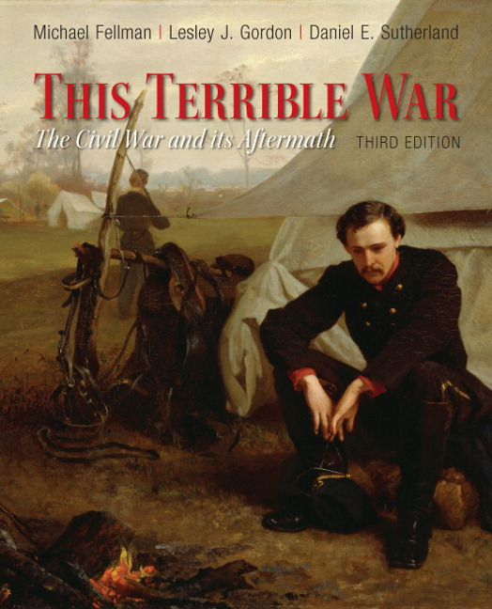

ISBN-13: | 9780205007912

The ISBN for the e-book is 9780205933778

Supplemental readings may also be supplied by the instructor in BLACKBOARD.

Online: You can access the course's online component at your My CSU on Blackboard. All QUIZ and DISCUSSION BOARDS are there.
All your online writing work will be posted there.

General Information

Course Description
A study of the factors leading to and the events of the AMERICAN CIVIL WAR and RECONSTRUCTION, and their results.

Argument

It is our belief that many of the major elements that formed the modern world were present or born in the terrible war that divided the country. What happened in the US in the mid-1800s and especially from 1861 to 1865 shaped who we are today, for good or for ill. In some ways, we are still fighting the Civil War today, and dealing with its legacy and the legacy of the slavery and racism, so antithetical to the American ideal of equality and democracy, that brought it about.

Assignments and grading

Assignments will consist of online written journals, quizzes and tests based upon the readings or on lecture videos. Grade breakdown TBA

Course Objectives
Upon successful completion of the course the student should be able to:
A. Demonstrate understanding of early American history by examining themes present then as they relate to the problems of today
B. Demonstrate analytical competence in identifying theme/thesis, main points, and supporting details of a reading selection;
C. Demonstrate the ability to write about assigned and self-invented writing assignments;
D. Demonstrate ability to apply appropriate methodology and content from other disciplines to assigned and self-invented writing assignments;
E. Demonstrate an ability to write an assignment reflecting his or her understanding with organization, logic, adequate development, coherence, and significance;
F. Demonstrate an awareness of the main themes that shaped history in the Western Hemisphere
G. Demonstrate ability to write informed critical analyses about works of history
H. Use rhetorical methods to demonstrate ability to write interpretive papers based upon both fiction and nonfiction;
I. Discuss and write about the objectivity and reliability of information found in essays;
J. Identify and analyze problems found in historical writing
K. Demonstrate recognition of cause and effect relationships in history
L. Demonstrate ability to integrate new facts and ideas with personal experience in assigned and self-invented writing assignments;

Online Journal Grade Characteristics for review of readings, etc.
A JOURNAL- 20 points
Clear, well stated thesis statement; well organized development with logical support for statements made; well stated conclusion which reflects the thesis statement; no major errors (fragments, run-on sentences); three or fewer minor errors in punctuation, spelling or grammar; appropriate vocabulary and sentence structure. With 2 SUBSTANTIVE responses to other discussions- stating your opinion in relation to the post- agree, disagree with at least 3 articulate reasons why you feel the way you do.
B JOURNAL 16 points
Good thesis statement adequately presented; organized development with support for most statements made; conclusion which reflects the thesis statement; three or fewer major errors (fragments, run-on sentences); six or fewer minor errors in punctuation, spelling or grammar; vocabulary and sentence structure reflect course level. With 2 LESS SUBSTANTIVE responses or NO RESPONSES to other discussions- stating your opinion in relation to the post- agree, disagree with at least 1 articulate reason why you feel the way you do.
C JOURNAL 14 points
Discernible thesis statement; some developmental organization with support for some statements made; conclusion evident; five or fewer major errors (fragments, run-on sentences); several minor errors in punctuation, spelling or grammar; pedestrian vocabulary and sentence structure. With NO SUBSTANTIVE responses to other discussions- stating vague opinion in relation to the post- and/or supplying no reasons why you feel the way you do.
D JOURNAL 12 points
Vague thesis statement; poor organization with little support for statements made; vague conclusion; several major errors (fragments, run-on sentences); many minor errors in punctuation, spelling or grammar; vocabulary and sentence structure below college level.
With NO SUBSTANTIVE responses to other discussions- stating vague opinion in relation to the post- and/or supplying NO reasons why you feel the way you do.
F paper 11 OR LESS
Lacks thesis statement; organization not evident; lack of conclusion; many major and minor errors; vocabulary and sentence structure on primary level and monotonous and little or no substantive response to at least 2 other posts.

EXTRA CREDIT is always given if you respond SUBSTANTIVELY to more than 2 posts. CREDIT will be taken off for late work.

Policies
Attendance
Regular class attendance is required, to be measured by timely submission of assignments online. The College’s attendance policy, to be found in the Catalogue, will be adhered to. For purposes of this class, the policy means that after two absences the student may be withdrawn. If the official withdrawal date has passed and the student accumulates more than the allowed number of absences, the student will fail the class for reasons of non-attendance.

Withdrawal Date
Students who cannot complete a course MUST OFFICIALLY WITHDRAW from the course. Withdrawals are accepted in person in the office of Admissions and Records during regular office hours; by certified letter sent directly to the Office of Admissions and Records. Failure to attend the course does not constitute an automatic withdrawal.

Tardiness
Students are expected to arrive on time for class. Arriving late shows a lack of respect for classmates. Two tardy arrivals will be considered an absence.

Assignment Dates
Assignments are due on the date designated on the schedule. Individual absence on the due date does not extend the assignment due date. Papers submitted after the due date will be penalized a half letter grade for every day it is late. Should the student anticipate an absence on the date an assignment is due, work should be turned in online- email or post on blackboard. No excuses will be accepted for online work which is done at the time of your convenience.

Disabilities
Any student who, because of a disabling condition, may require some special arrangement in order to meet course requirements, should contact the Access Office.

Intellectual Dishonesty
To plagiarize is defined by The American Heritage College Dictionary as “to use and pass off as one’s own work (the ideas or writing of another).” This means that all academic work will be done by the student to whom it is assigned, without unauthorized aid of any kind. An act of plagiarism could result in a failing grade for the document(s) in question.

The CSU Dept. of History adds the following with regard to plagiarism:
Using someone else's ideas or phrasing and representing those ideas or phrasing as our own, either on purpose or through carelessness, is a serious offense known as plagiarism. "Ideas or phrasing" includes written or spoken material, of course — from whole papers and paragraphs to sentences, and, indeed, phrases — but it also includes statistics, lab results, art work, etc. "Someone else" can mean a professional source, such as a published writer or critic in a book, magazine, encyclopedia, or journal; an electronic resource such as material we discover on the World Wide Web; another student at our school or anywhere else; a paper-writing "service" (online or otherwise) which offers to sell written papers for a fee.
Source: Capitol Community College's guide to plagiarism (based on the MLA style): http://webster.commnet.edu/mla/plagiarism.shtml

Individual Questions
Individual questions are welcome and encouraged. There is a Discussion Board set up where you can consult each other and me about technological glitches as well as other issues that may come up with regard to readings and quizzes.

